# Required components for each view

**General App:**

tpmodal (May not need as will just put as the default view without having to click the search button. aka no option for the autocomplete thing)

tp-plain:

Main title at the top of the page

tp-button:

For the clear button at the top of the page

tp-tabs:

Used to house the two tabs that are needed for this view (Selection and results)

**Supplier Map Search:** 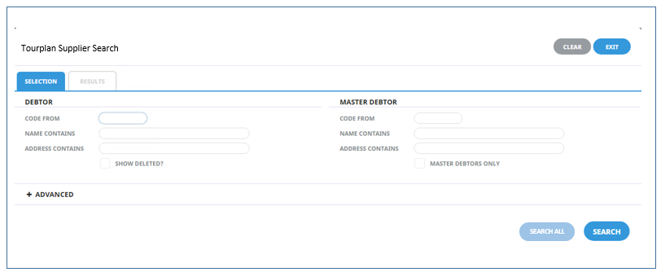

tp-tab:

so the view knows it is currently on the Selection Tab

tp-group:

Groups together a section

tp-label:

Gives txt to a description

tp-code:

Special type of inputbox for supplier codes

tp-description:

Special type of inputbox for longer descriptions

tp-checkbox:

Checkbox needed to specify search criteria

tp-button:  
Needed to click search or to search all

**Supplier Map Results:**

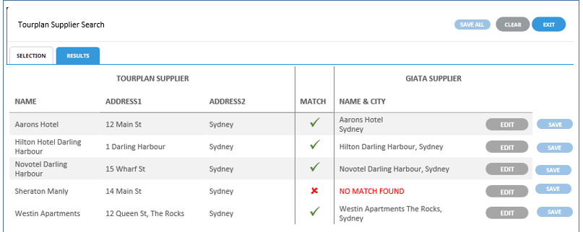

tp-tab:

so the view knows it is currently in the results tab

tp-grid:

Sets up the results in a table format

tp-column:

one of the attributes of the tp-grid

tp-button:

Needed for the saving of the matches as well as saving/editing individual matches

tp-label:

Gives txt to a section of the grid

**Select A Supplier:**

tp-grid:

Needed to set up all suppliers in a drop down list

tp-column:

Individual attributes of the tp-grid

tp-label:

Most of the elements within the grid are txt and need to be set to this

tp-button

the user needs to be able to select a certain supplier to apply that mapping ( may not need as there is an option for a selectable list)

